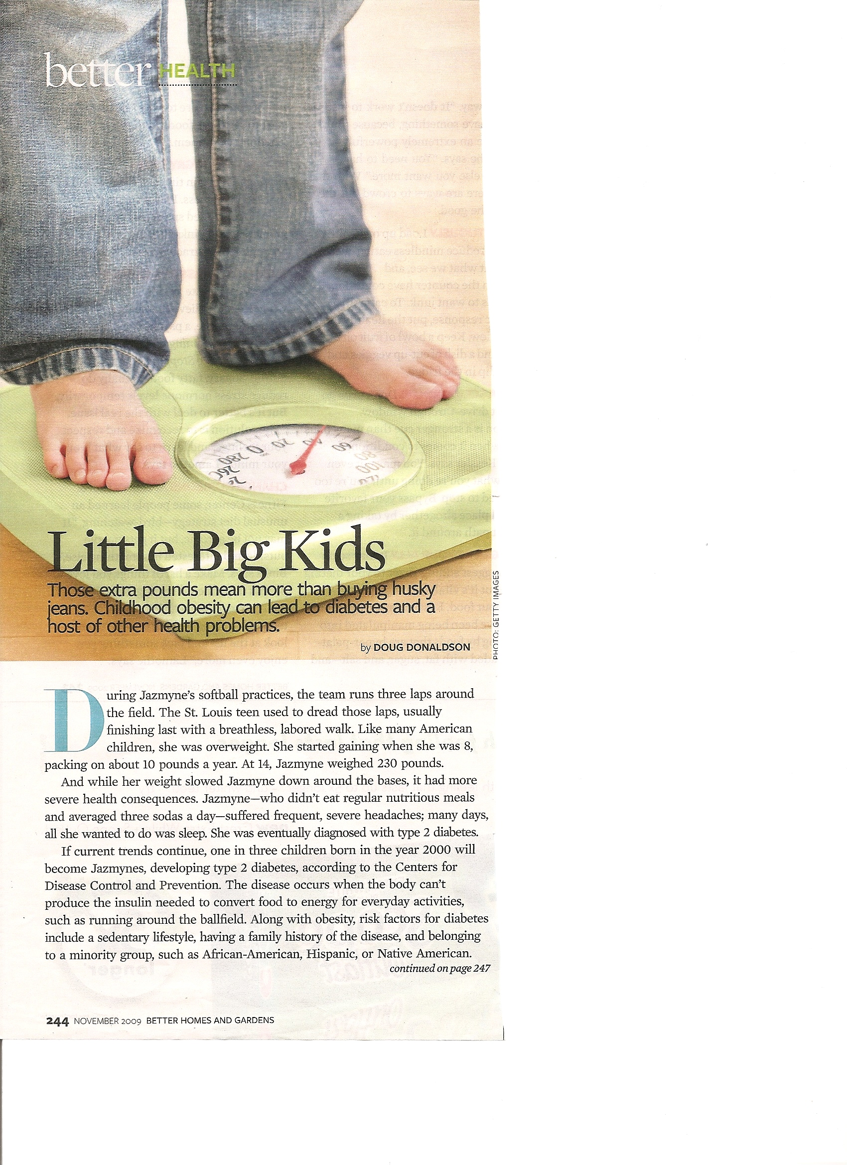 **Name: ________________________**

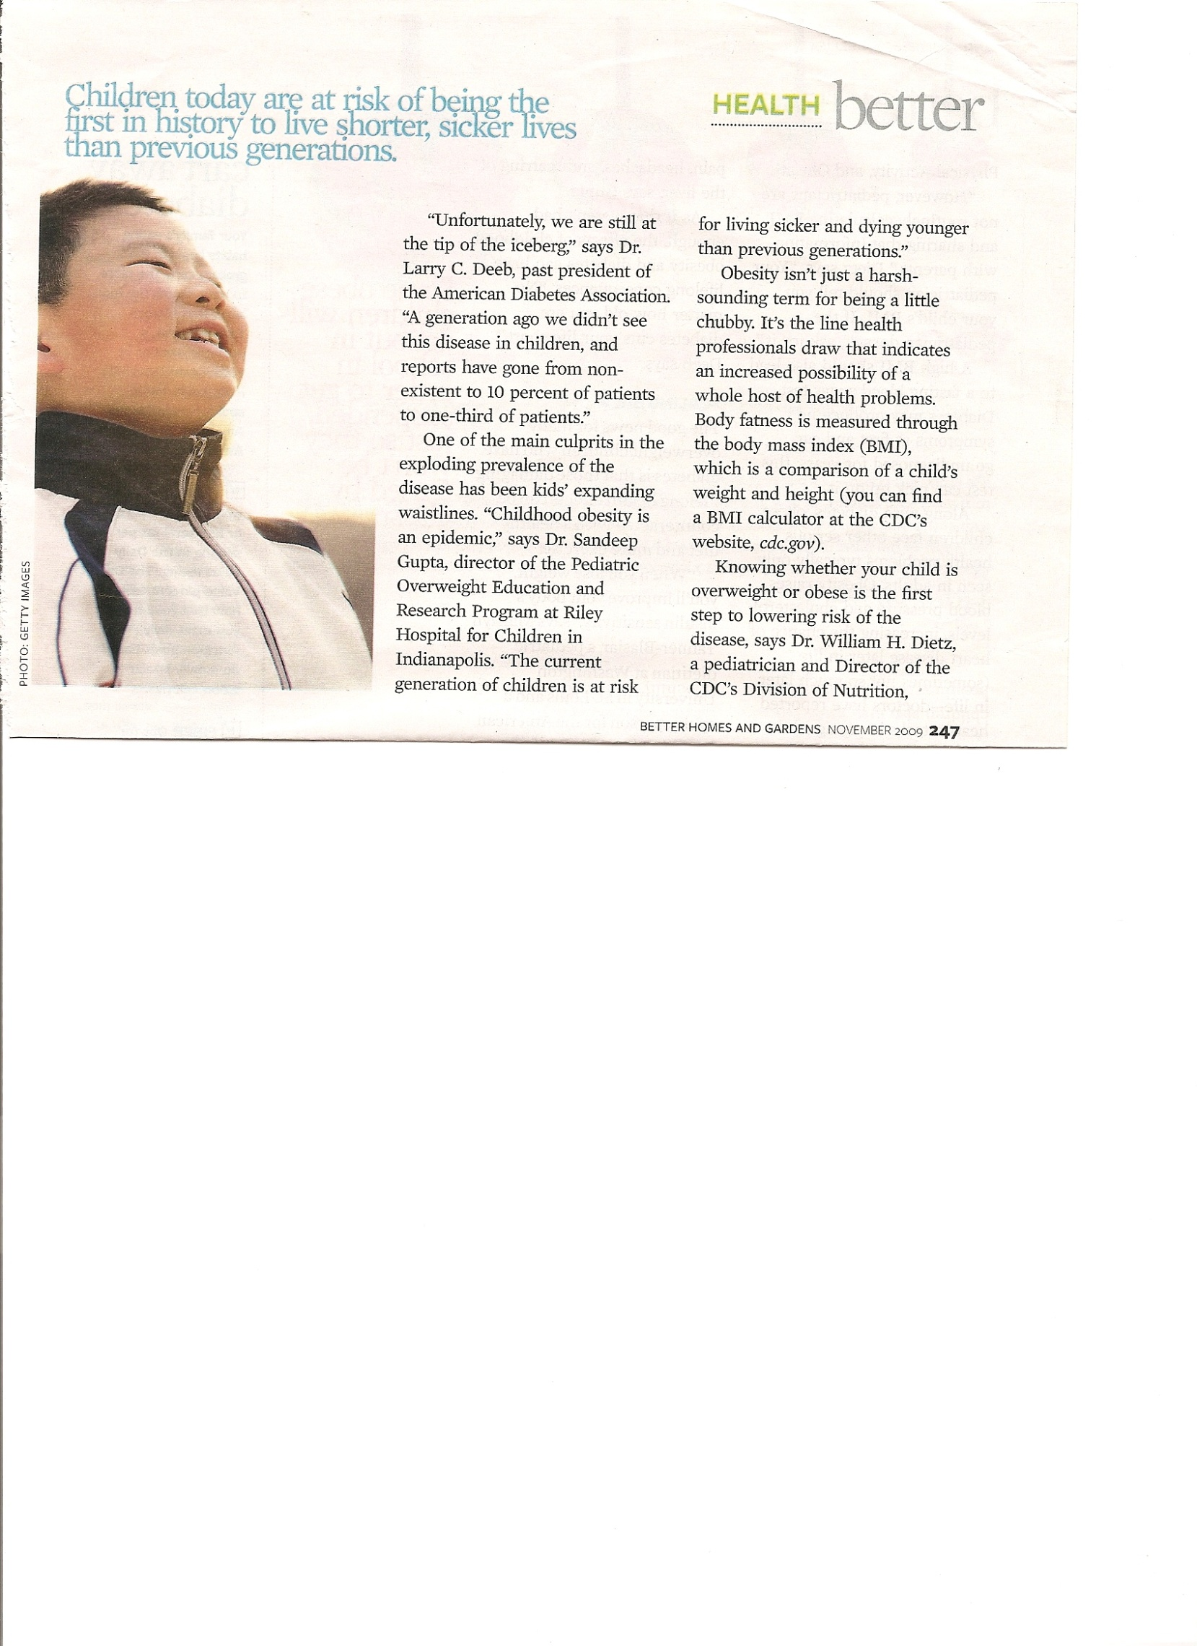 **Date: ___________ Block: _______**

**Read the following article and answer the questions at the end.**

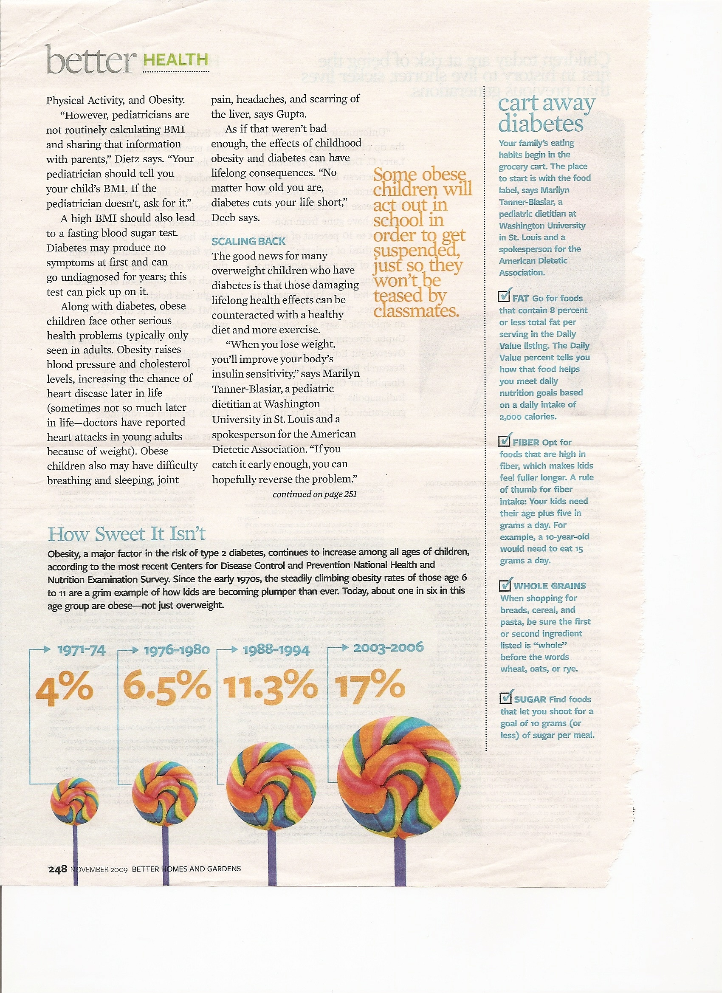

1. 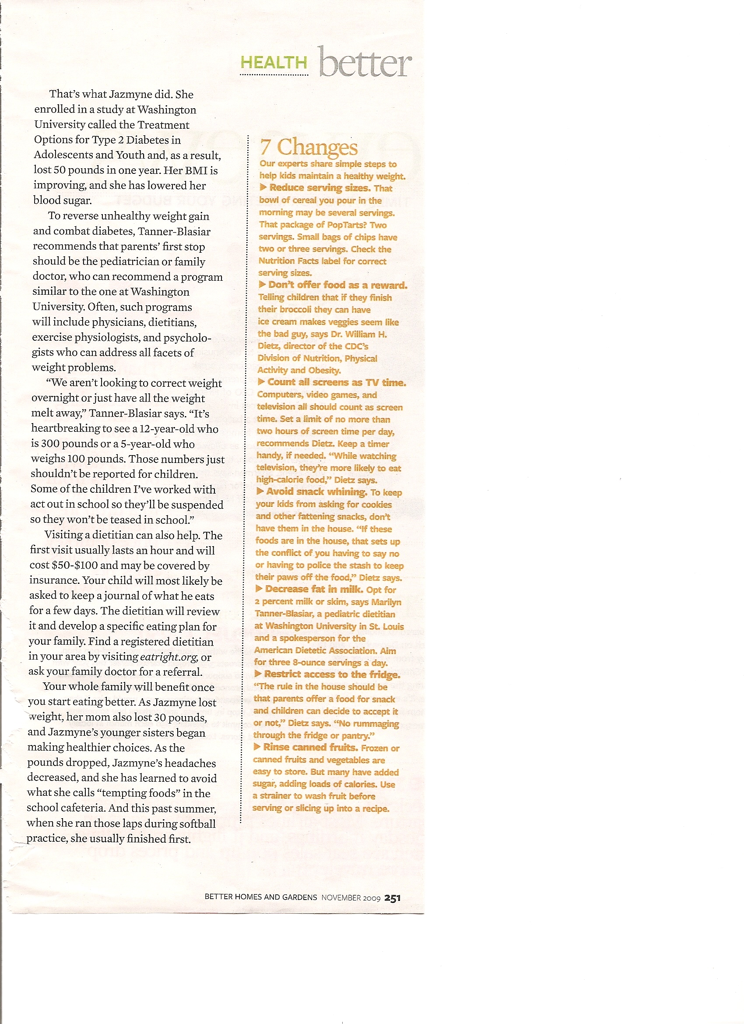What are three causes of childhood obesiety and type 2 diabetes?